K23-0593

Muhammad Ayesh

Lab#01

Task#01:

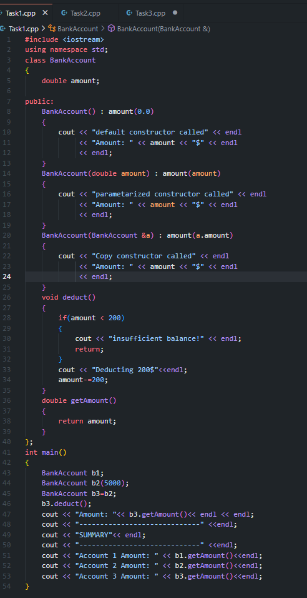

Task#02:

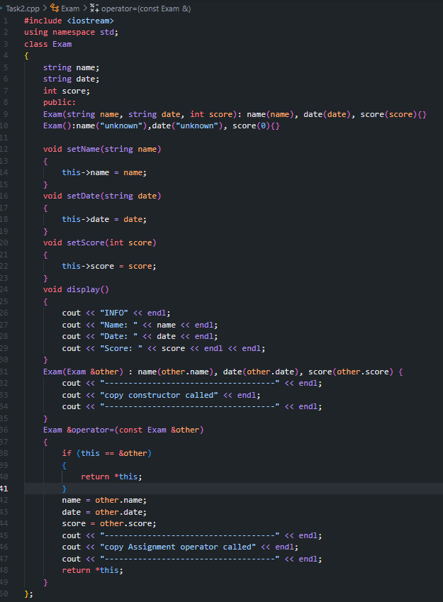

Task#03:

